**My projects:-**

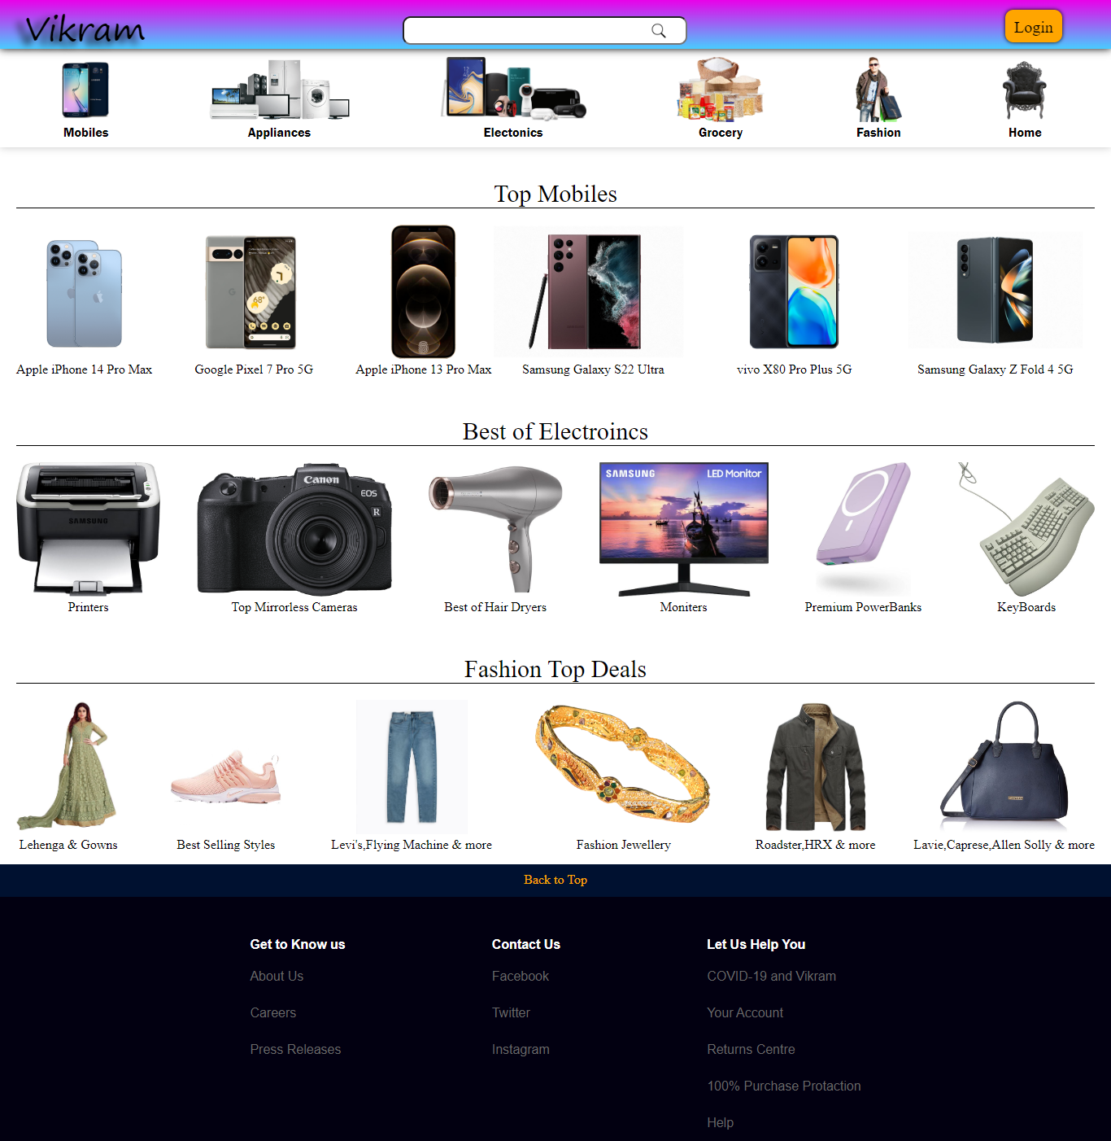

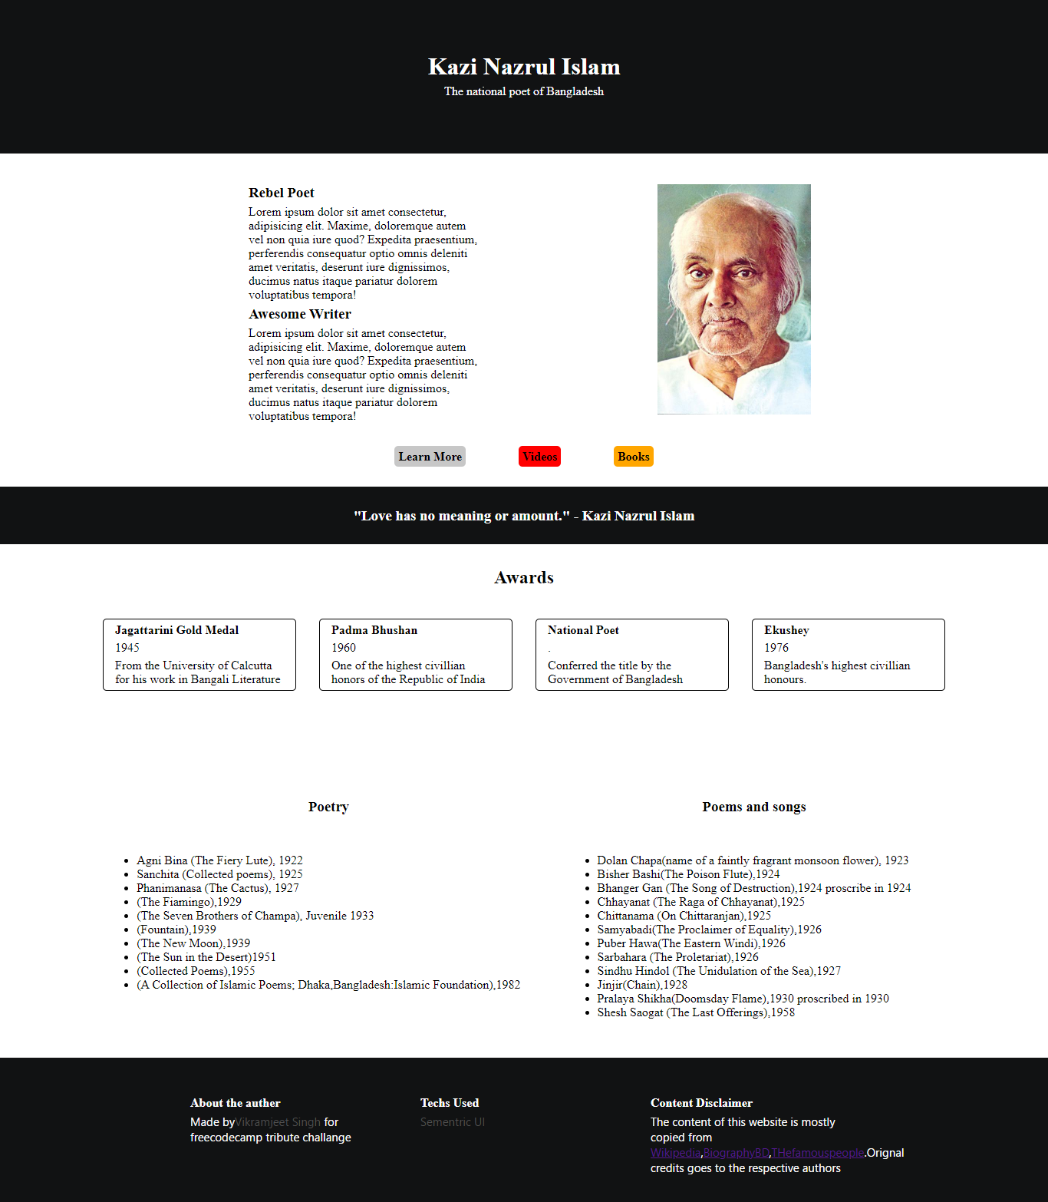

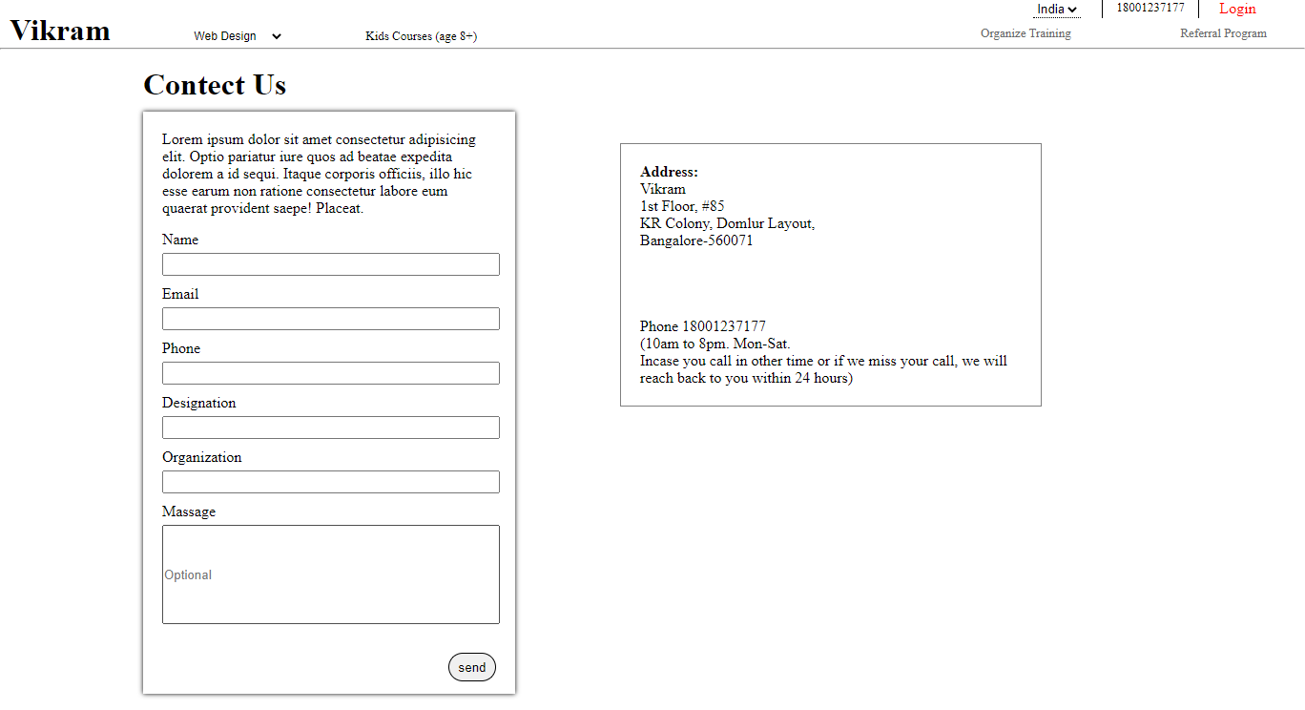

**Name:-** Vikramjeet Singh

**Mobile no. :-** 9813170911

**Email-Id** :- [jeev129@gmail.com](mailto:jeev129@gmail.com)

**Career Objective**

* To associate myself with an organization that provides for me an excellent opportunity to show my techno proficient skill , improve my knowledge and to be part of team that works dynamically towards growth of organization .

**Educational Qualification**

* I.T.I ( Electrician ) NCVT from D.R.M I.T.I Khiarekan,Haryana,Sirsa
* Senior Secondary from Board of Bhiwani Education,Haryana,Sirsa
* Secondary from Board of Bhiwani Education,Haryana,sirsa

**Skills**

* Basic computer knowladg
* Creativity
* Positivity
* Problam solving abilities
* Basic photoshop Knowledge
* HTML & CSS Knowled

**Hobbies**

* Music
* Learning
* Cricket
* Badminton
* Gym
* Playing an Guitar

**Personal Detail**

* Father Name:- Sucha singh
* Mother Name:- Amarjeet Kaur
* Nationality:- Indian
* Gender:-Male
* Date of Birth:-20/10/2000
* Martial Status:- Single
* Language:-Punjabi,Hindi,English

**Location**

* V.p.o.Kuttabadh,Sirsa,Haryana

**Current Location**

* Surya Vihar,sector-4,gurgaon,Haryana

Vikramjeet Singh